# Project -1 Machine Learning

# Fire Alram Predictor

In this project, we will work with Fire alram.csv dataset to develop a machine learning algorithm that predicts the fire. A model like this would be very valuable to predict the fire using temperature, humidity, pressure etc.

### Problem Statement

Develop a model that has the capacity of predicting fire by making use of the information provided in fire alram Dataset

### Dataset

The dataset used in this project consists of 14 variables: The main variable we are interested is 'Fire Alram’. This variable predicts the fire in the area based on the inputs given in dataset

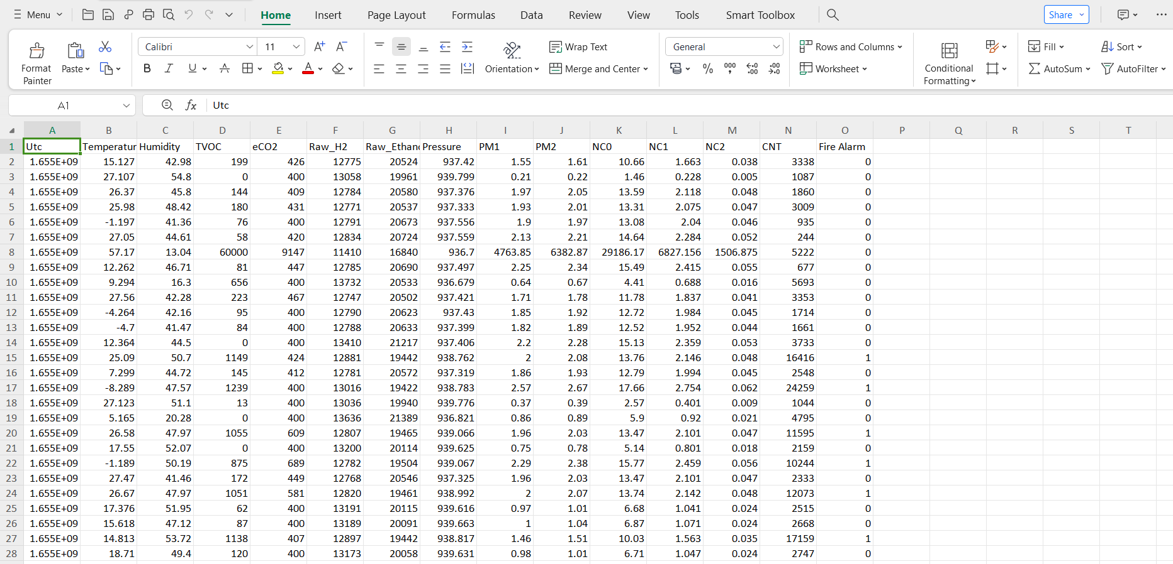

The overview of the original dataset is shown in figure with its original features:

### Algorithm –Random Forest Algorithm

It is a very simple python program to implement. Multiple regression is like linear regression, but with more than one independent value, meaning that we try to predict a value based on two or more variables. Random forest algorithm is implemented using the RandomForestClassifier and estimators class from sklearn.linear_model library.

* 1. **Programming Steps**
* This project requires us to predict the condition of surroundings based on the given input dataset.
* First, we read the given dataset using pandas function.
* Then we print the inputs and output from csv file.
* We initialize the model i.e., Random Forest Algorithm.
* We further implement this using Django in order for better representation

### Code:

import pandas as pd path="C:\\Users\\swathi\\OneDrive\\Desktop\\7_smokedetectorclassification\\train_dataset.csv" data=pd.read_csv(path)

print(data)

print(data.shape) #very large data set inputs=data.drop('Fire Alarm',axis=1) output=data['Fire Alarm'] print(inputs)

print(output) import sklearn

from sklearn.model_selection import train_test_split x_train,x_test,y_train,y_test=train_test_split(inputs,output,test_size=0.2) print(x_train)

print(x_test) print(y_train) print(y_test)

from sklearn.ensemble import RandomForestClassifier model=RandomForestClassifier(n_estimators=50) model.fit(x_train,y_train)

y_pred=model.predict(x_test)

print(y_pred) print(y_test)

UTC=int(input("Enter the UTC value:")) Temperature=float(input("Enter the temperature")) Humidity=float(input("Enter the humidity")) TVOC=int(input("Enter the TVOC[ppb] value ")) eCO2=int(input("Enter the eCO2[ppm] value ")) Raw_H2=int(input("Enter the raw h2 value ")) Raw_Ethanol=int(input("Enter the Raw ethanol value ")) Pressure=float(input("Enter the Pressure value ")) PM1=float(input("Enter the PM1 value: ")) PM2=float(input("Enter the PM2 value :")) NC0=float(input("Enter the NC0 value :")) NC1=float(input("Enter the NC1 value :")) NC2=float(input("Enter the NC2 value :")) CNT=int(input("Enter the CNT value :"))

res=model.predict([[int(UTC),float(Temperature),float(Humidity),int(TVOC),int(eCO2),int(Raw_H2),int( Raw_Ethanol),float(Pressure),float(PM1),float(PM2),float(NC0),float(NC1),float(NC2),int(CNT)]])

print(res) if res==1:

print("Fire is on!!!!!")

else:

print("Fire is off!!!!!!!!!!!!")

## OUTPUT:

